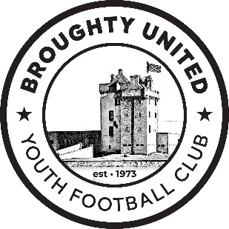
Health and Safety Policy
Broughty United Community Club SCIO
Last updated | 15/01/2026

The Club is committed to a safe environment for all players, volunteers (all levels) and coaches. It will promote standards of health, safety and welfare within football and will ensure compliance with all relevant statutory provisions. We will ensure that suitable and sufficient risk assessments are carried out, that procedures and safe systems are implemented in accordance with all current statutory provisions and that all reasonable and practical measures are taken to avoid risk. Safe practices will be adopted, and continuous improvement will be sought through regular audits and reviews.
Appropriate instruction and training will be provided together with adequate resources to ensure that the successful management of health and safety is carried out within the club and that this policy is collectively implemented. This policy together with arrangements and procedures, will be reviewed regularly and revised and regularly updated, as necessary.

HEALTH & SAFETY POLICY:
To support our Health & Safety policy statement we are committed to the following duties:
- Undertake regular, recorded risk assessment of the Club’s premises and all activities undertaken by the affiliated teams.
- Create a safe environment by putting health & safety measures in place as identified by the assessment.
- Ensure that all members are given the appropriate level of training and competition by regularly assessing individual ability dependant on age, maturity and development.
- Ensure that all Club Members are aware of, understand and follow the club’s health & safety policy.
- Ensure that normal operating procedures and emergency operating procedures are in place and known by all members.
- Provide access to adequate first aid facilities, telephone and qualified first aider at all times.
- Report any injuries or accidents sustained during any club activity or whilst on the club premises.
- Ensure that the implementation of the policy is reviewed regularly and monitored for effectiveness.

AS A CLUB MEMBER YOU HAVE A DUTY TO:
- Take reasonable care for your own health & safety and that of others who may be affected by what you do or not do.
- Co-operate with the Club on all Health & safety issues.
- Correctly use all equipment provided by the club.
- Not interfere with or misuse anything provided for your health, safety or welfare.
- Keep an up-to-date register of your activity with Emergency Contact Details
FIRST AID:
The DECSC defibrillator is in a cabinet next to the main entrance to the Quest Arena (Whitton Park). The Broughty United defibrillator is kept in the cabinet on the west wall of the pavilion at Orchar Park.
Each team must also have their own First Aid Kit, a minimum of one qualified First Aider and have use of a mobile phone in case of emergency.

END OF POLICY

